GAS PROCESSING & METHANOL COMPLEX PROJECT NO. 11998A

Project | FEED for Gas Gathering Pipelines & Associated Infrastructure
Client | Brass Fertilizer and Petrochemical Company Limited
Originating Company | Epic Atlantic Limited
Document Title | Pipe Stress Analysis Report -ELEPA
Document Number | EA-BFPCL-GPMC-GGPL-FEED-MPP-RPT-003
Document Revision | R01
Document Status | Issued for Review
Originator | Israel Osobase
Security Classification | Restricted
Issue Date | 08-Aug-22

Pipe Stress Analysis Report-ELEPA

R01 | 08.08.22 | Issued for Review | I. Osobase | E. Nwachukwu | A. Duru
Rev # | Issue Date | Status  Description | Originator | Reviewer | Approver  (Epic) | Approver  (BFPCL)

Revision History
Rev No. | Date | Description of Revision
R01 | 08.08.22 | Issued for Review

Revision Philosophy:
- All documents for review shall be issued at R01, with subsequent R02, R03, etc as required.
- All documents approved for issue or approved for design shall be issued at A01 with subsequent A02, A03, etc. as required. (Management of Change is required for A02, A03, etc.)
for the subsequent project phases, post FEED, it is expected that:
- All Detailed Design documents for review shall be issued at D01, with subsequent D02, D03, etc. as required.
- All documents approved for construction shall be issued at C01 with subsequent C02, C03, etc. as required. (Management of Change is required for C02, C03, etc.)
- All approved “As-Built” documents shall be issued at Z01, with subsequent Z02, Z03, etc as required. (Use versions Z01.1, Z01.2, Z01.3, etc to review the “As-Built” document to Z02).

Restricted
This document is made available subject to the condition that the recipient will neither use nor disclose the contents except as agreed in writing with the copyright owner. Copyright is vested in Brass Fertilizer and Petrochemical Company Limited (BFPCL) © All rights reserved.
Neither the whole nor any part of this document may be reproduced or distributed in any form or by any means (electronic, mechanical, reprographic, recording, or otherwise) without the prior written consent of the copyright owner.

SUMMARY PAGE
Client: | Brass Fertilizer & Petrochemical Company Limited
Project: | Gas Processing & Methanol Complex | Project No. 11998A
Facility: | Gas Gathering Pipelines & Associated Infrastructure | Doc No.  EA-BFPCL-GPMC-GGPL-FEED-MPP-RPT-003

The administration of this document is in respect of FEED for Gas Gathering Pipelines & Associated Infrastructure for the Gas Processing & Methanol Plant Project of BFPCL.
The Pipelines will be implemented in two phases, - starting with BBOU & ELEP as Phase 1and followed by NUNR, SEIB & OPUG as Phase 2. The focus of the present FEED is on Phase 1, while Phase 2 will be implemented later.
It is also a precursor and accompaniment to the FEED study & report that will lead to the project’s FID and implementation.
The report has relied on and used data and reference documents provided by the client, and if further documents and information become available, Epic Atlantic reserves the right to update the opinion set out in this report.
For better appreciation, this document should be read in conjunction with the references listed below, which are the Concept Select Study reports that constitute basis for the Conceptual Study.
KEYWORDS: BASIS OF DESIGN, PIPELINE, MANIFOLD, PLATFORM, MULTIPHASE FLOW, ROW, PTS

REferences
Document No. | Description
EA-BFPCL-GPMG-GGPL-FEED-PSE-RPT-001 | Upstream Gas Gathering Concept Select & Revalidation Report
EA-BFPCL/BFPP GAS PL/FEED-PRO-RPT-001 | Preliminary Simulation – Based on Desktop Route Survey
EA/SPDC-BFPC UGS-GEP/CSM-RPT-002 | Gas Gathering & Evacuation Pipelines Concept Screening
EA/SPDC-BFPC UGS-GEP/CSM-RPT-001 | Conceptual Study Memorandum
EA-BFPCL-GPMC-GGPL-FEED-GEN-RPT-002 | Basis of Design
 | FISAS Draft ESIA Report (November 2020)

Table of Contents
Abbreviations 5
1. Introduction 6
1.1. Background Information 6
1.2. Purpose 7
2. Regulations, Codes And Standards 8
2.1. Project Technical Documents 8
2.2. Shell Specifications 8
2.3. International Codes and Standards 9
2.4. System of Units 9
2.5. Safety 9
3. Definition of Concepts 10
3.1. Support Definitions 10
3.2. Geometry and system Model 10
3.2.1 Coordinate System and Degrees of Freedom 10
4. Analysis Basis and Assumptions 11
4.1. General 11
4.2. Boundary Condition 11
4.3. Virtual Anchor 11
5. Input Data 12
5.1. Lines Analysed 12
5.2. Environmental data 13
5.3. Friction Coefficient 13
5.4. Load definitions 14
5.5. Load Cases Considered 14
5.6. Load Combinations 15
6. Result Summary 16
6.1. Stress Summary 16
6.2. Maximum Displacements 17
6.3. Maximum Restraint Forces 17
7. Conclusion 19
8. List of Attachments 20
Attachment A; Input Listing 20
Attachment B; Analysis results 20
Attachment C; Screen shot from Autopipe 20
Attachment D; Stress Isometrics 20

Abbreviations
ABBREVIATIONS | MEANING
AED | Anti-Explosive Decompression
ASME | American Society of Mechanical Engineers
ASTM | American Society for Testing and Materials
API | American Petroleum Institute
BS | British Standard
CS | Carbon Steel
DBB | Double Block and Bleed
ENP | Electroless Nickel Plated
HFE | Human Factor Engineering
ISO | International Organisation for Standardization.
MESC | Material & Equipment Standard and Code
MMscf/d | Million standard cubic feet per day
MSS | Manufacturers Standardisation Society
MTO | Material Take Off
NDE | Non-Destructive Examination
NPT | Nominal Pipe Threaded
NPS | Nominal Pipe Size
RTJ | Ring Type Joint
SPE | Society of Petroleum Engineers.
SS | Stainless Steel
SW | Socket Weld

Introduction

Background Information
Brass Fertilizer and Petrochemical Company Limited (BFPCL) is developing a 10,000 metric tonnes per day (MTPD) capacity greenfield methanol production facility in Akabel (Odioma), Brass LGA, Bayelsa state. The plant complex is to be based on natural gas feedstock from 5 SPDC fields in OMLs 33, 35 & 36.
The Project involves the development, construction, and operation of a plant comprising:
- Two trains of 5,000 MTPD methanol plant, producing a total of 10,000 MTPD of methanol
- 340 MMscfd Gas Processing Plant (“GPP”), which will extract NGL from the natural gas feedstock, prior to feeding the lean gas to the methanol plant.
- Gas gathering pipelines and associated manifolds transporting the natural gas from five fields, viz: Bubouwe Bou (BBOU), Elepa (ELEP), Nun River (NUNR), Seibou (SEIB), and Opugbene (OPUG) to the GPP at Akabel.
- Product Export Lines and SBM for the export of the methanol, and NGL of the GPP.
- All offsite, utility, and off-plot facilities (including product storage, internal power generation, steam generation, and export jetty) for the operation of the processing plants.
The Pipelines will be implemented in two phases, - starting with BBOU & ELEP as Phase 1 and followed by NUNR, SEIB & OPUG as Phase 2.
The focus of the present FEED is on Phase 1 as shown in figure 1 below, while Phase 2 will be implemented later.
TCE is the Project Management Consultant for the project.
Figure 1: Gas Gathering Concept, Phase 1

Purpose
The purpose of this document is to present the result of the stress analysis carried out on the pipeline and piping systems of Elepa facility which comprises of Manifold header, 36” Pig launcher and receiver and a 24” Pig receiver
The analysis is based on the methodology for the computerized stress analysis.
The governing code for this analysis is piping code ASME B31.3 and B31.8.
The following shall be ensured;
- That the stresses induced are within the allowable limits as per the applicable code.
- To ensure that it has inherent flexibility to accommodate thermal displacements due to design/operating conditions without imposing excessive loads on pipe supports and equipment nozzles limits as per the applicable code.
- That the stresses induced are within the allowable limits as per the applicable code.
- The piping system behaviour is within permissible limits for the given design parameters in the given piping layout and terminal boundary conditions.
- The piping system is adequately supported to prevent vibration, excessive displacement and system resonance

Regulations, Codes And Standards
The latest versions of the regulations, codes, and standards and extant amendment or supplements shall apply. Local laws regulating the oil and gas industry in Nigeria shall be strictly adhered to. The order of precedence for the documents shall be as follows:
- Nigerian Local Standards and Codes
- The Contract
- Project Specifications
- Employer’s Standards
- Shell DEPs
- International Codes and Standards
In all cases, the most stringent shall apply except where constraints dictate otherwise.
Conflicts between specifications and referenced Codes and Standards or deviations thereof shall be referred in a Technical Query (TQ) to the EMPLOYER for resolution.

Project Technical Documents
Key Project Technical Specifications are listed below.
REF | DOCUMENT NUMBER | TITLE
[1] | EA-BFPCL-GPMC-GGPL-FEED-GEN-RPT-002 | Basis of Design
[2] | EA-BFPCL-GPMC-GGPL-FEED-MPP-SPC-005 | Piping Class Specification
[3] | EA-BFPCL-GPMC-GGPL-FEED-MPP-SPC-015 | Specification for Piping
[4] | EA-BFPCL-GPMC-GGPL-FEED-PSE-DWG-003 | Process Engineering Flow Sheets (PEFS) Elep Facilty
[5] | EA-BFPCL-GPMC-GGPL-FEED-MPP-DWG-015 | General Piping Arrangement Drawing - ELEPA
[6] | EA-BFPCL-GPMC-GGPL-FEED-MPP-DWG-024 | Pipe Supports Location Drawing - ELEPA
[7] | EA-BFPCL-GPMC-GGPL-FEED-MPP-LST-012 | Critical Line List- ELEPA

Shell Specifications
The following DEPs are applicable:
 | DOCUMENT NUMBER | TITLE
[8] | DEP 31.38.01.25-Gen | Piping -Process Design Requirements
[9] | DEP 31.38.01.10-Gen | Piping classes – basis of design
[10] | DEP 31.38.01.14-Gen | Piping classes
[11] | DEP 31.38.01.24-Gen | Piping – Engineering and Layout Requirements
[12] | DEP 31.38.01.26-Gen | Piping – Pipe Stress Analysis Requirements

International Codes and Standards
REF | DOCUMENT NUMBER | TITLE
[13] | ASME B31.8 | Gas Transmission and Distribution Piping Systems
[14] | ASME B31.3 | Process Piping Code
[15] | ASME B36.10M | Welded and Seamless Wrought Steel Pipe
[16] | API 5L | Specification for Line Pipe
[17] | ASME B16.5 | Steel Pipe Flanges NPS ½ through NPS 24
[18] | ASME B16.20 | Metallic Gaskets for Pipe Flanges
[19] | ASME B31.3 | Process Piping Code
[20] | ASME B16.5 | Steel Pipe Flanges NPS ½ through NPS 24
[21] | ASME B16.20 | Metallic Gaskets for Pipe Flanges

System of Units
In general, the SI system of units shall be used for the Project, with the following exceptions:
- Pipe spanning shall be in millimeters
- Flange ratings shall be in pounds as per ASME B16.5
- Pressure shall be in bar.
- Pipe size shall be in inches.
- All other units are based on metric standard unit system.

Safety
Safety is the primary consideration during design and all risks associated with the design shall be minimized by adhering to the relevant governing legislation, regulations, design codes, and accidental procedural requirements.

Definition of Concepts

Support Definitions
Definition of restraints used are given bellow. The effect of frictional resistance to steel surfaces in contact is considered by a static friction coefficient of 0.3 (steel / steel)
symbol | Restrain and support type
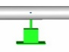 | V-stop or Rest supports restrain the pipe in vertical direction. Acts only downwards
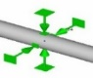 | Guide supports restrain all directions expect in axial direction of the pipe. Modelled with a gap of 3mm in all directions except downwards to allow some unrestricted thermal expansion.
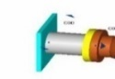 | Anchor Restrains pipe movement in all direction.

Geometry and system Model
The geometry used for the modelling of the piping system analyzed is based on the revised updated PDMS model.
A unique node number was assigned to all points in the model indicating where there is a support, piping items like valve, transition point, change in diameter, wall thickness, material, temperature, or pressure, or a change in direction.

Coordinate System and Degrees of Freedom
The coordinate system for this AutoPIPE stress analysis model is the right-hand rule, with the +Y direction pointing upwards, X direction parallel to the pipeline axis and Z direction perpendicular to the afore - mentioned axis. See Figure below for coordinate system. Each location has six degrees of freedom, represented with three translational movements X, Y and Z and three rotational movements RX, RY and RZ.
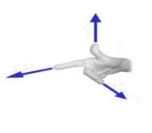
Z
Y
X

Analysis Basis and Assumptions

General
- The ratio of calculated stress with material allowable stress shall be less than 1.0 in all cases.
- The basis for stress analysis, loading methods are specified in the technical specification for piping stress analysis and approved by client prior to the commencement of this analysis.
- Software for the computerized stress analysis shall be Bentley AutoPIPE Advanced version 12.5 or higher versions
- The loads considered in this analysis are pressure, temperature, weight (live and dead loads), wind, vibration reactions, thermal expansion and contraction, temperature gradients. However, earthquake-induced horizontal and vertical forces are not considered.
- There are no dynamic conditions for the piping system. Surge, slug, seismic and other forms of vibrations are not considered.
- The occasional effect of wind is considered with a projected application method, and a ground datum of 1m. No wind load shall be applied below this elevation. The wind speed is 35.6m/s
- For hydrotest load case, a pressure factor of 1.5 shall be applied on the design pressure in accordance with ASME B31.3 for Process Piping while a pressure factor of 1.25 shall be applied on design pressure as per ASME B31.8 for Pipelines and Pig Receiver
- This report presents analysis for lines classified as piping (per ASME B31.3) and Pipeline (per ASME B31.8) in code break of P&IDs (EA-BFPCL-GPMC-GGPL-FEED-PSE-DWG-003). For the purpose of this analysis, the system is anchored at all interfaces between piping and pipeline to achieve individual system reaction to service loads as per governing codes.
- Pipe routing is based on the Latest PDMS 3D Model routing.
- Flange and valve Loads (weight) are taken from the software library catalogue.
- All piping materials as identified in Specification for Piping Material Class
- The minimum natural frequency of the system shall be maintained at a threshold limit of 3 Hz.

Boundary Condition
All lines within Elepa facility shall be considered not buried in this analysis, therefore active length required to form a virtual anchor has been calculated and it shall span from interface between buried and above ground pipe to the point of anchorage at one end to get realistic boundary conditions of the system.

Virtual Anchor
Virtual anchor has been considered for the buried segments of the 36” and 24” pipelines, the system was modelled with a calculated virtual anchor generated at nodes A00/P16 for 36” pipelines with length of 560m and 249m calculated length for 24” pipeline at node S14. The detailed calculation and input data are in Attachment A

Input Data
In addition to the following data, input data is automatically generated by Autopipe program and form part of the analysis report. See Attachment A

Lines Analysed
PIPELINE (ASME B31.8 SCOPE)
- ELEP-36"-PL-012-X70-CL900
- EPEP-36-PL-011-X70-E
- ELEP-24-P-0013-C06
PIPING (ASME B31.3 SCOPE)
- ELEP-12”-P-014-C03
- ELEP-36”-P-0013-C06
- ELEP-4"-P-016-C06
- ELEP-36"-P-017-C06
- ELEP-24”-P-0013-C06
- ELEP-36”-P-003-C06
- ELEP-X-P-002-C70
- BBOU-24”-PF-XXXX-120-E
- ELEP-6”-B-005-B06
- ELEP-4"-P-016-C06_B
- ELEP-4"-P-021-C06
- ELEP-XX-B-007-B06
- ELEP-4"-P-021-C06_B
- ELEP-XX-B-007-B06_B
- ELEP-6”-B-005-B06
- ELEP-4"-P-0016-C06
- ELEP-6”-B-005-B03_B
- ELEP-6”-P-006-C06
- ELEP-6”-B-003-B06
- ELEP-6”-P-007-C06
- ELEP-6”-B-004-B06
- ELEP-6”-B-001-B06
- ELEP-6”-B-007-B06
- ELEP-12”-P-019C06
- ELEP-8"-P-014-C06

Environmental data
Parameters | Values
Ambient Temperature | 23°C
Prevailing wind direction | south-west
Basic wind speed | 35.6 m/s
Ground elevation for wind load application | From grade
Wind shape factor (referred as force coefficient per ASCE) | 1
Wind specification type | ASCE-7-10*
Wind exposure | Category C as per ASCE-7-10
Wind application method | Projected **
Wind direction | Global +X, -X, +Z , -Z

*ASME B31.3 section 301.5.2 refers wind load analysis of exposed piping to the procedures in ASCE 7
**The projected area of pipe perpendicular to the direction of the wind is used to determine the magnitude of the wind force. The wind force is then applied to the pipe in the direction of the wind.

Friction Coefficient
The coefficient of friction between supporting interface (i.e., the junction between Top of Steel and Bottom of Pipe) shall be applied at all vertical restraints (Ref. Specification for stress analysis)
Material in Contact | Surface Condition | Friction Coefficient
 |  | Static | (Sliding)
Metal on metal | Dry | 0.5-0.8 | 0.4
Teflon on metal | Dry | 0.05-0.2 | 0.1

Load definitions
S/No | Load case | Description
1 | Gr | Dead weight of pipe and content
2 | T1 | Max design temperature, 60/100 ºC
3 | T2 | Operating temperature, -29/12ºC
4 | T3 | Ambient temp. 23 ºC
5 | P1 | Design pressure, 1.96 /11 N/mm2,
6 | P2 | Max Operating pressure, 10 N/mm2
7 | Hydro.P | Hydrotest pressure; 1.5 * P1 @T3, 1.25*P1 @ T3
8 | Wind 1 | Projected Wind load in Global +X direction @ basic wind speed at 38 m/s, from 2m datum analyzed to ASCE-7-2010
9 | Wind 2 | Projected Wind load in Global -X direction @ basic wind speed at 38 m/s, from 2m datum analyzed to ASCE-7-2010
10 | Wind 3 | Projected Wind load in Global +Z direction @ basic wind speed at 38 m/s, from 2m datum analyzed to ASCE-7-2010
11 | Wind 4 | Projected Wind load in Global -Z direction @ basic wind speed at 38 m/s, from 2m datum analyzed to ASCE-7-2010
12 | G | Gravity

Load Cases Considered
The following single and combination load sequence are considered for AutoPipe non-linear analysis of stress, moments and forces result at all nodal point.

Load Combinations
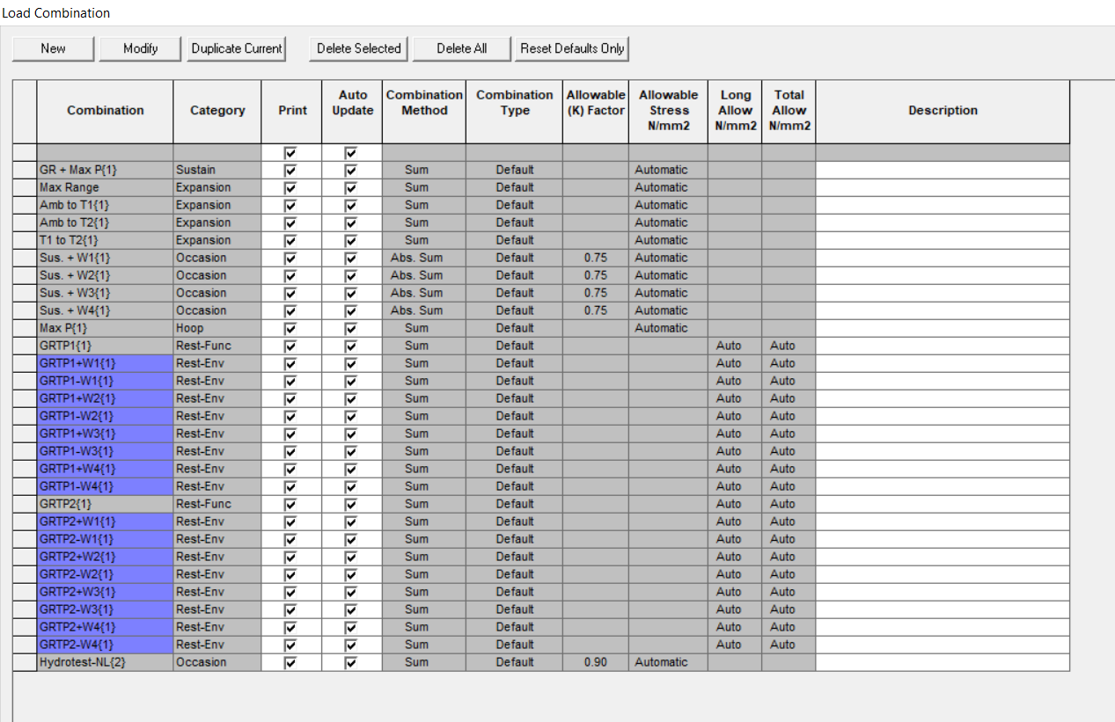
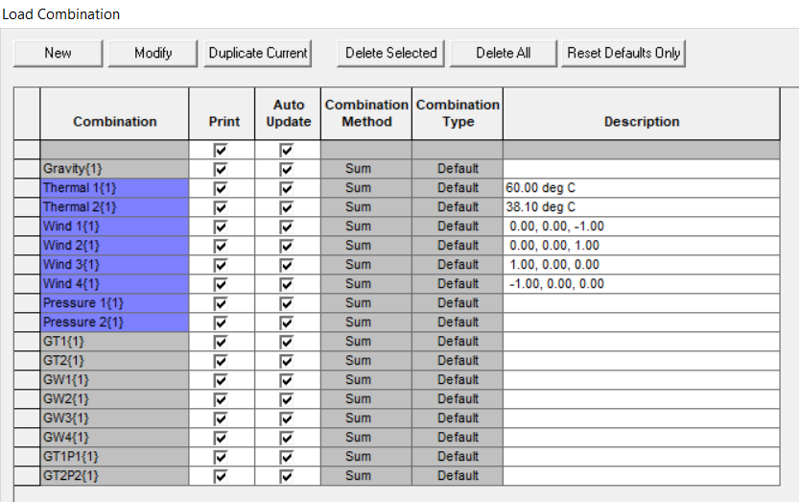
See attachment A for a full list of AutoPIPE load cases

Result Summary
In the following tables, calculated stress values at Nodal points are reported.
For each tabulation, the maximum stress is given, the point at which it occurs, the load combination, and the ratio between calculated and code allowable stresses.

Stress Summary
Analysis for pipeline and piping section was included in this report, and the calculation was done in accordance with ASME B31.8 and ASME B31.3, respectively.
The ASME B31.8 scope refers to pipeline section comprising underground and aboveground pipeline including the Pig receiver/launcher (ELAP-A-100, ELAP-A-200 and ELAP-A-300).
The ASME B31.3 scope refers to piping systems, manifold header and vent lines.
For each section, the basis of analysis and findings will be as per the applicable code.
Such that in the case of applicability of ASME B31.3, only results in piping section will be taken into consideration and that of the pipeline section will be ignored. Same applies for ASME B31.8 on the pipeline section.
- ASME B31.3 Maximum code Stresses
Stress Category | Nodal Point | Max. Stress Value (N/mm2) | Allowable Stress (N/mm2) | Ratio | Load Combination
Maximum sustained stress | S04 N | 125 | 188 | 0.66 | GR + Max P
Maximum displacement stress | T03 | 118 | 207 | 0.57 | Max Range
Maximum occasional stress | R00 | 187 | 434 | 0.43 | Hydrotest-NL
Maximum hoop stress | X03 | 148 | 172 | 0.86 | Max P
Maximum sustained stress ratio | S04 N | 125 | 188 | 0.66 | GR + Max P
Maximum displacement stress ratio | T03 | 118 | 207 | 0.57 | Max Range
Maximum occasional stress ratio | S04 N | 125 | 250 | 0.50 | Sus. +W3
Maximum hoop stress ratio | X03 | 148 | 172 | 0.86 | Max P
The system is within the allowable stresses check for all load cases.

- ASME B31.8 Maximum code Stresses
Stress Category | Nodal Point | Max. Stress Value (N/mm2) | Allowable Stress (N/mm2) | Ratio | Load Combination
Maximum sustained stress | R00 | 144 | 362 | 0.40 | GR + Max P
Maximum displacement stress | S10 F | 101 | 331 | 0.30 | Amb to T1
Maximum occasional stress | R00 | 183 | 434 | 0.42 | Hydrotest-
Maximum hoop stress | B04 | 233 | 347 | 0.67 | Max P
Maximum sustained stress ratio | R00 | 144 | 362 | 0.40 | GR + Max P
Maximum displacement stress ratio | S10 F | 101 | 331 | 0.30 | Amb to T1
Maximum occasional stress ratio | R00 | 183 | 434 | 0.42 | Hydrotest-
Maximum hoop stress ratio | B05 | 140 | 174 | 0.81 | Max P
The system is within the allowable stresses check for all load cases.

Maximum Displacements
Direction | Displacement(mm) | Node | Load combination
Maximum X | 22 | O00 | GT1P1
Maximum Y | 22 | A04 | GT1P1
Maximum Z | 68 | P17 | W3

Maximum Restraint Forces
Direction | Restraint forces (N) |  | Node | Load combination
Maximum X | 5358453 |  | R03 | GT1P1
Maximum Y | -333344 |  | A07 | GT2
Maximum Z | 8221721 |  | A00 | GT1P1
ABBREVIATIONS |  | MEANING
AED |  | Anti-Explosive Decompression
ASME |  | American Society of Mechanical Engineers
ASTM |  | American Society for Testing and Materials
API |  | American Petroleum Institute
BS |  | British Standard
CS |  | Carbon Steel
DBB |  | Double Block and Bleed
ENP |  | Electroless Nickel Plated
HFE |  | Human Factor Engineering
ISO |  | International Organisation for Standardization.
MESC |  | Material & Equipment Standard and Code
MMscf/d |  | Million standard cubic feet per day
MSS |  | Manufacturers Standardisation Society
MTO |  | Material Take Off
NDE |  | Non-Destructive Examination
NPT |  | Nominal Pipe Threaded
NPS |  | Nominal Pipe Size
RTJ |  | Ring Type Joint
SPE |  | Society of Petroleum Engineers.
SS |  | Stainless Steel
SW |  | Socket Weld

Conclusion
In conclusion, the following has been established for the system:
- Results show all calculated stresses (sustained, expansion and occasional cases) are within allowable limits as per ASME B31.8
- Results show all calculated stresses (sustained, expansion and occasional cases) are within allowable limits as per ASME B31.3
- The first natural frequency of both systems is above 3Hz as specified in section 4.1

List of Attachments

Attachment A; Input Listing

(Component data, material properties and allowable stress values, Load cases description, Hydrotest data, Temp and pressure, Soil parameters, other input data.)

Attachment B; Analysis results

Attachment C; Screen shot from Autopipe

Attachment D; Stress Isometrics

